Basic and Important Git command while working on any coding or development Task

**git config :**

This command sets auther name and email address respectively to use in you commits. It is important to set email and name so that your work can be identified.

Format :

* git config --global user.name “ Your Name”
* git config --global user.email “email@address”





**git init :**

This command is used to initialise and creates new git repository. This is very first and important command you have to execute to run other git command. Most git command wont run without init command.

Format :

* git init



**git clone :**

This command is used to copy or clone remote repository to target repository. We can clone specific folder, tag or branch of the repository.

* git clone {URL of Repository}



**git add:**

This command is used to add files or changes in files to staging area. Before committing we have to add all the files to staging area.

Format :

* git add [Filename]
* git add .



**git status :**

This shows you which changes are staged and which are not staged. This normally use before committing any changes to check if everything is staged or not. It lets you see which changes have been staged, which haven't, and which files aren't being tracked by Git.

Format :

* git status

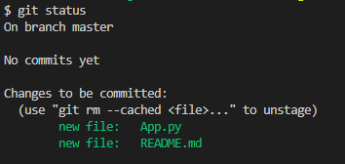

**git commit :**

This will commit whatever the changes which are there in staging area and prepare code to push to main repository.

Format :

* git commit -m “Message”

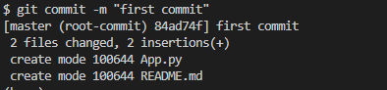

**git rename branch:**

This is used to rename the branch.

Format :

* git branch -m master main



**git push:**

This will be use to push the code to main repository

Format :

* git push origin main

**git remote add :**

Sometime while pushing code it ask to add origin at that time we have to add origin where we want to push the code.

Format :

* git remote add {URL}
* 

**git remote :**

List the remote connections you have to other repositories.

Format :

* git remote

**git branch :**

This command showcase how many branches are there that already exist for current development cycle

Format :

* git branch
* 

**git branch {NAME} :**

This command creates new branch which stores copy of main and then there we can fix bug or do additional development later we can merge it to main branch.

Format :

* git branch {Name}
* 

**git checkout {NAME} :**

This command is used to switch the branch among existing.

Format :

* git checkout {Name}
* 

**git merge main:**

This command is used to merge branches. TO merge branch switch to parent branch and then run command of merge branch and name of branch

Format :

* git merge {Name}
* 

**git branch -d {branchname}:**

This command is use to delete branch

Format :

* git branch -d {branchname}
* 